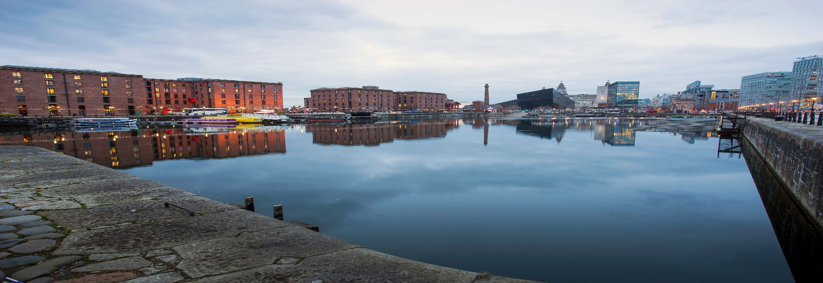

**Draft DWMP Consultation**

Our consultation was open for 12 weeks and officially closed on the 22nd September. In total we received 59 responses, with 26 responses of these from stakeholders. Overall we are pleased that the feedback was mostly positive from our stakeholders, particularly that from the Environmental Agency.

**Ofwat** quoted: *“We consider that your dDWMP was generally well structure and technically well developed”*

We are currently in the process of analysing the data from our consultation responses to formulate key themes ready for the formal response publication on the 15th December 2022. We will be in touch about this in more detail in due course.

**20th October 2022, Edition 5**

Email: [DWMP@uuplc.co.uk](mailto:DWMP@uuplc.co.uk)

**Welcome** to our fifth DWMP E-Newsletter. A lot has been happening over the past few months, with our last newsletter being before draft publication in June! In this edition we will bring you up to date with the feedback from our consultation responses and the outcomes of our stakeholder workshops.

*

We would like to thank everyone who joined us for our workshops held in September and for those who completed consultation responses.

*

If you have any questions, please do get in touch via **DWMP@uuplc.co.uk**

**DWMP E-Newsletter October 2022**

**Stakeholder Workshops - September 2022**

In early September, 70 stakeholders from 48 different organisations attended our Draft DWMP Consultation Workshops. Within these workshops stakeholder provided feedback to help us develop our DWMP and identify opportunities for partnership working.

The workshops were split into three sessions: Partnerships, Surface Water Management and The Preferred Plan. When asked what would encourage greater partnership working; funding, resource, communication and data sharing were ranked the most important considerations.

When asked about the preferred plan, 56% of participants agreed that “the DWMP gives useful insight into pressures and opportunities in the future and help with your planning processes”.

The feedback provided at these workshops will be incorporated into the changes to the DWMP between draft and final where possible.

**Green Recovery Funding**

Applications for our Green Recovery Fund are now open and we are looking for applications from partnership schemes identified through the DWMP Strategic Planning Group workshops.

The Green Recovery Fund is applicable to NFM and SuDS partnership opportunities within the GMCA, Irwell, Fylde Coast and Eden.

If you would like to apply or have any questions please contact us at: [DWMP@uuplc.co.uk](mailto:DWMP@uuplc.co.uk)

**Deadline: 25th November 2022**